OVERALL PROGRAMME EVALUATION REPORT
Social Entrepreneurship Program (SEP) – SCALE MASTERCLASS Module 2 (ONLINE)– Uganda (1st June 2026 - 5th June 2026)
No. of Respondents: 74
No. of Participants: 74
Response Rate: 100%
--------------------------------------------------

Faculty Reports

Dr. Chilumba K. Bwalya - Long-term sustainability planning
Evaluation Parameter | (%) Individual Score | (%) Programme Average
Punctuality (Commencement and Completion of Sessions) | 88 | 83
How well do you understand the core concepts presented? | 92 | 90
Rate your confidence in applying the new skills learnt | 80 | 83
Degree of Faculty preparedness for the sessions | 92 | 94
Content and methodology of the program | 92 | 93
Quality of class and group discussions | 92 | 90
The information presented in the course is relevant to my work (ministry) | 92 | 94
Average scores | 90 | 90

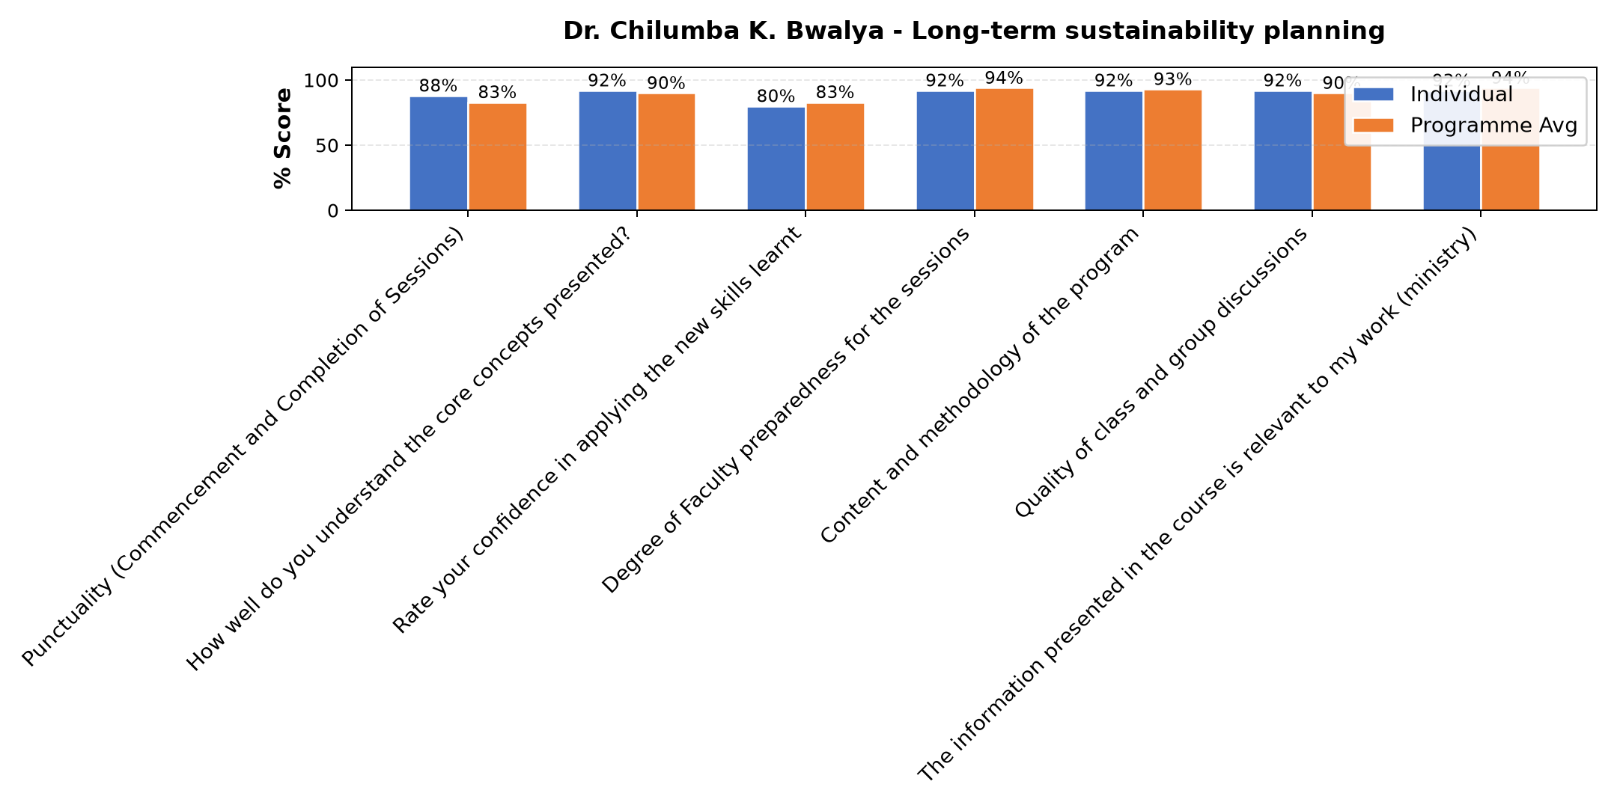

Comments & Feedback
- • My confidence
- • If am not informed

Dr. Nancy Njiraini - Reflections and Way Forward ||Wrap Up Session/ Questions and Answers, Next Steps
Evaluation Parameter | (%) Individual Score | (%) Programme Average
Punctuality (Commencement and Completion of Sessions) | 83 | 83
How well do you understand the core concepts presented? | 90 | 90
Rate your confidence in applying the new skills learnt | 87 | 83
Degree of Faculty preparedness for the sessions | 97 | 94
Content and methodology of the program | 97 | 93
Quality of class and group discussions | 93 | 90
The information presented in the course is relevant to my work (ministry) | 97 | 94
Average scores | 92 | 90

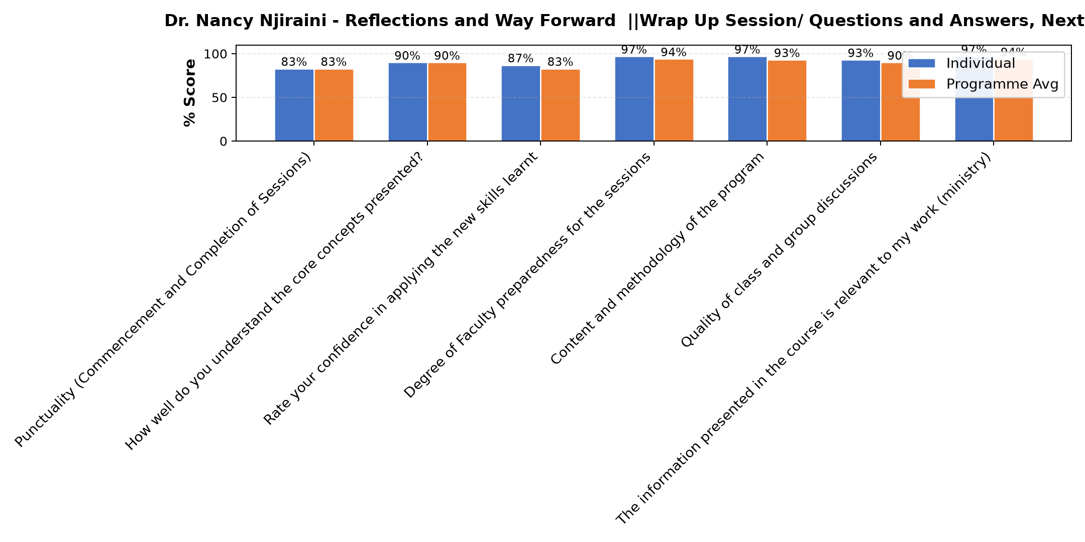

Comments & Feedback
- • Conflicting priorities – Day-to-day crises overshadow applying new knowledge.
Time Constraints — Running a nursery and primary school on a daily basis is demanding. Finding dedicated time to step back and work on the business rather than in it remains a significant challenge.
Limited Technical Expertise — Some of the funding application processes and impact measurement frameworks require technical skills that we may need additional support or training to fully implement.
Access to the Right Funders — Identifying and connecting with funders who specifically support early childhood education in our region can be difficult, especially without an established network.
- • Lack of data

Dr. James Onyoin - Review (identify gaps/challenges)
your business plan from module 1|| Decide key issues for long-term sustainability|| Identify areas where support is needed
Evaluation Parameter | (%) Individual Score | (%) Programme Average
Punctuality (Commencement and Completion of Sessions) | 75 | 83
How well do you understand the core concepts presented? | 90 | 90
Rate your confidence in applying the new skills learnt | 85 | 83
Degree of Faculty preparedness for the sessions | 90 | 94
Content and methodology of the program | 90 | 93
Quality of class and group discussions | 85 | 90
The information presented in the course is relevant to my work (ministry) | 90 | 94
Average scores | 86 | 90

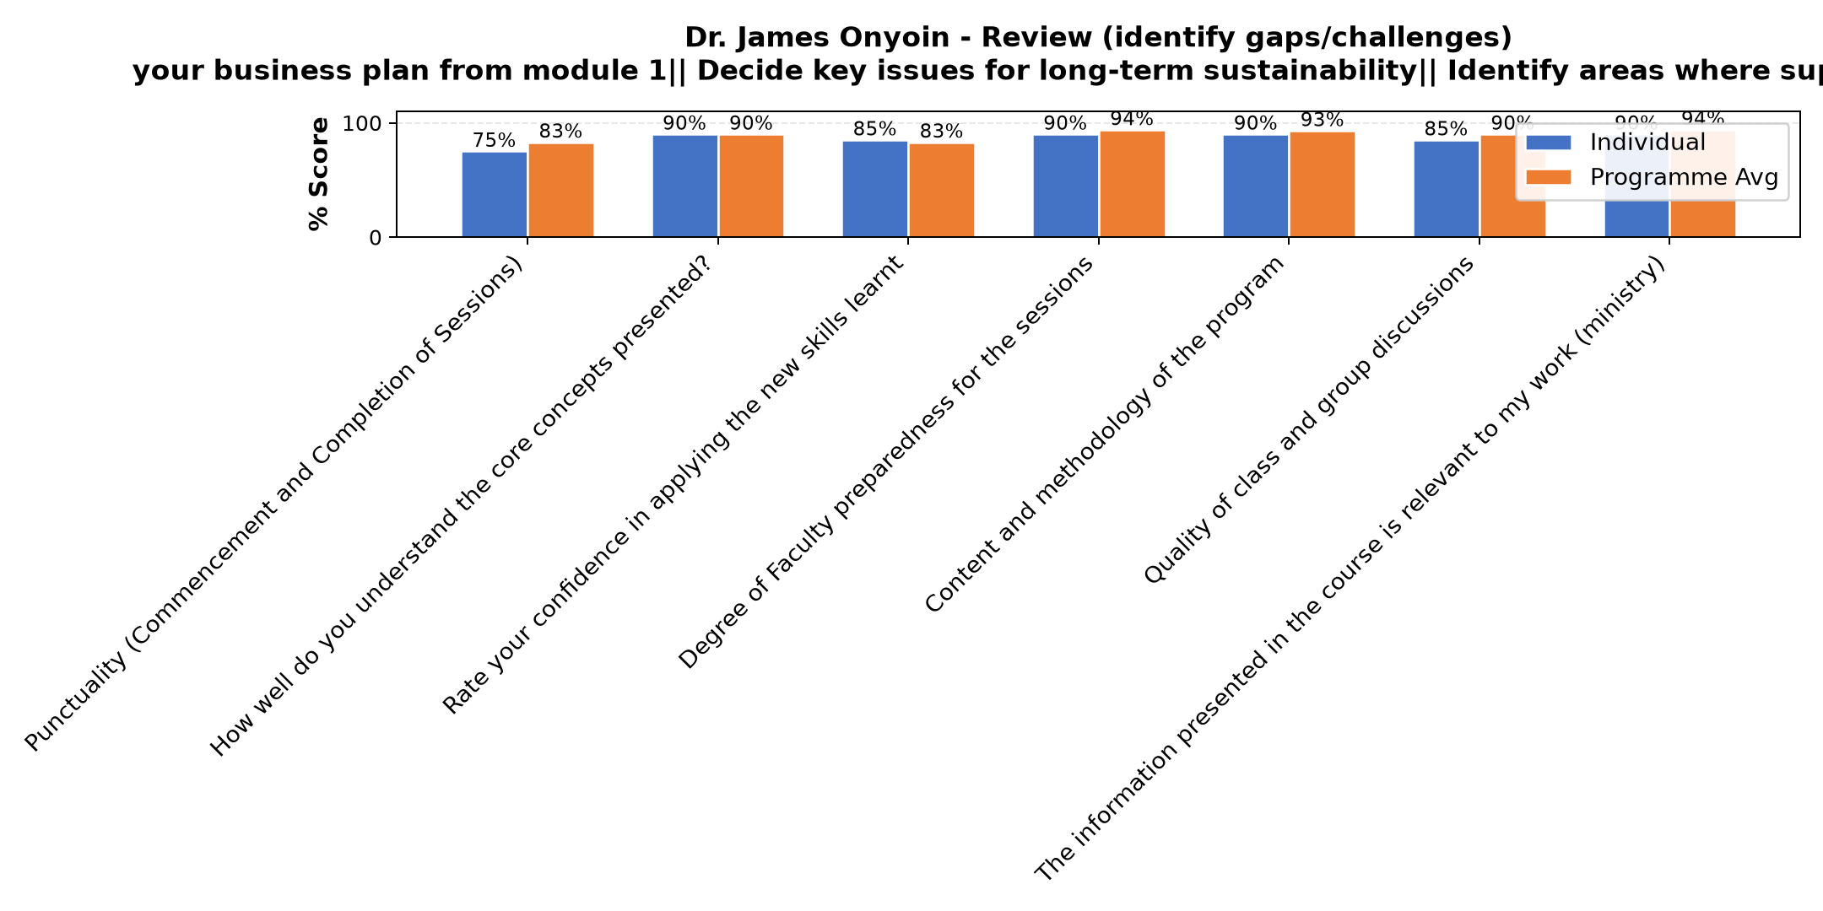

Comments & Feedback
- • Lack of enough time and data
- • Risk management
- • I will implement

Dr. Tom Buringuriza - Review current funding of social enterprise|| Identify Funding Gaps|| Preparing funding plan:
Evaluation Parameter | (%) Individual Score | (%) Programme Average
Punctuality (Commencement and Completion of Sessions) | 87 | 83
How well do you understand the core concepts presented? | 87 | 90
Rate your confidence in applying the new skills learnt | 73 | 83
Degree of Faculty preparedness for the sessions | 93 | 94
Content and methodology of the program | 93 | 93
Quality of class and group discussions | 93 | 90
The information presented in the course is relevant to my work (ministry) | 93 | 94
Average scores | 88 | 90

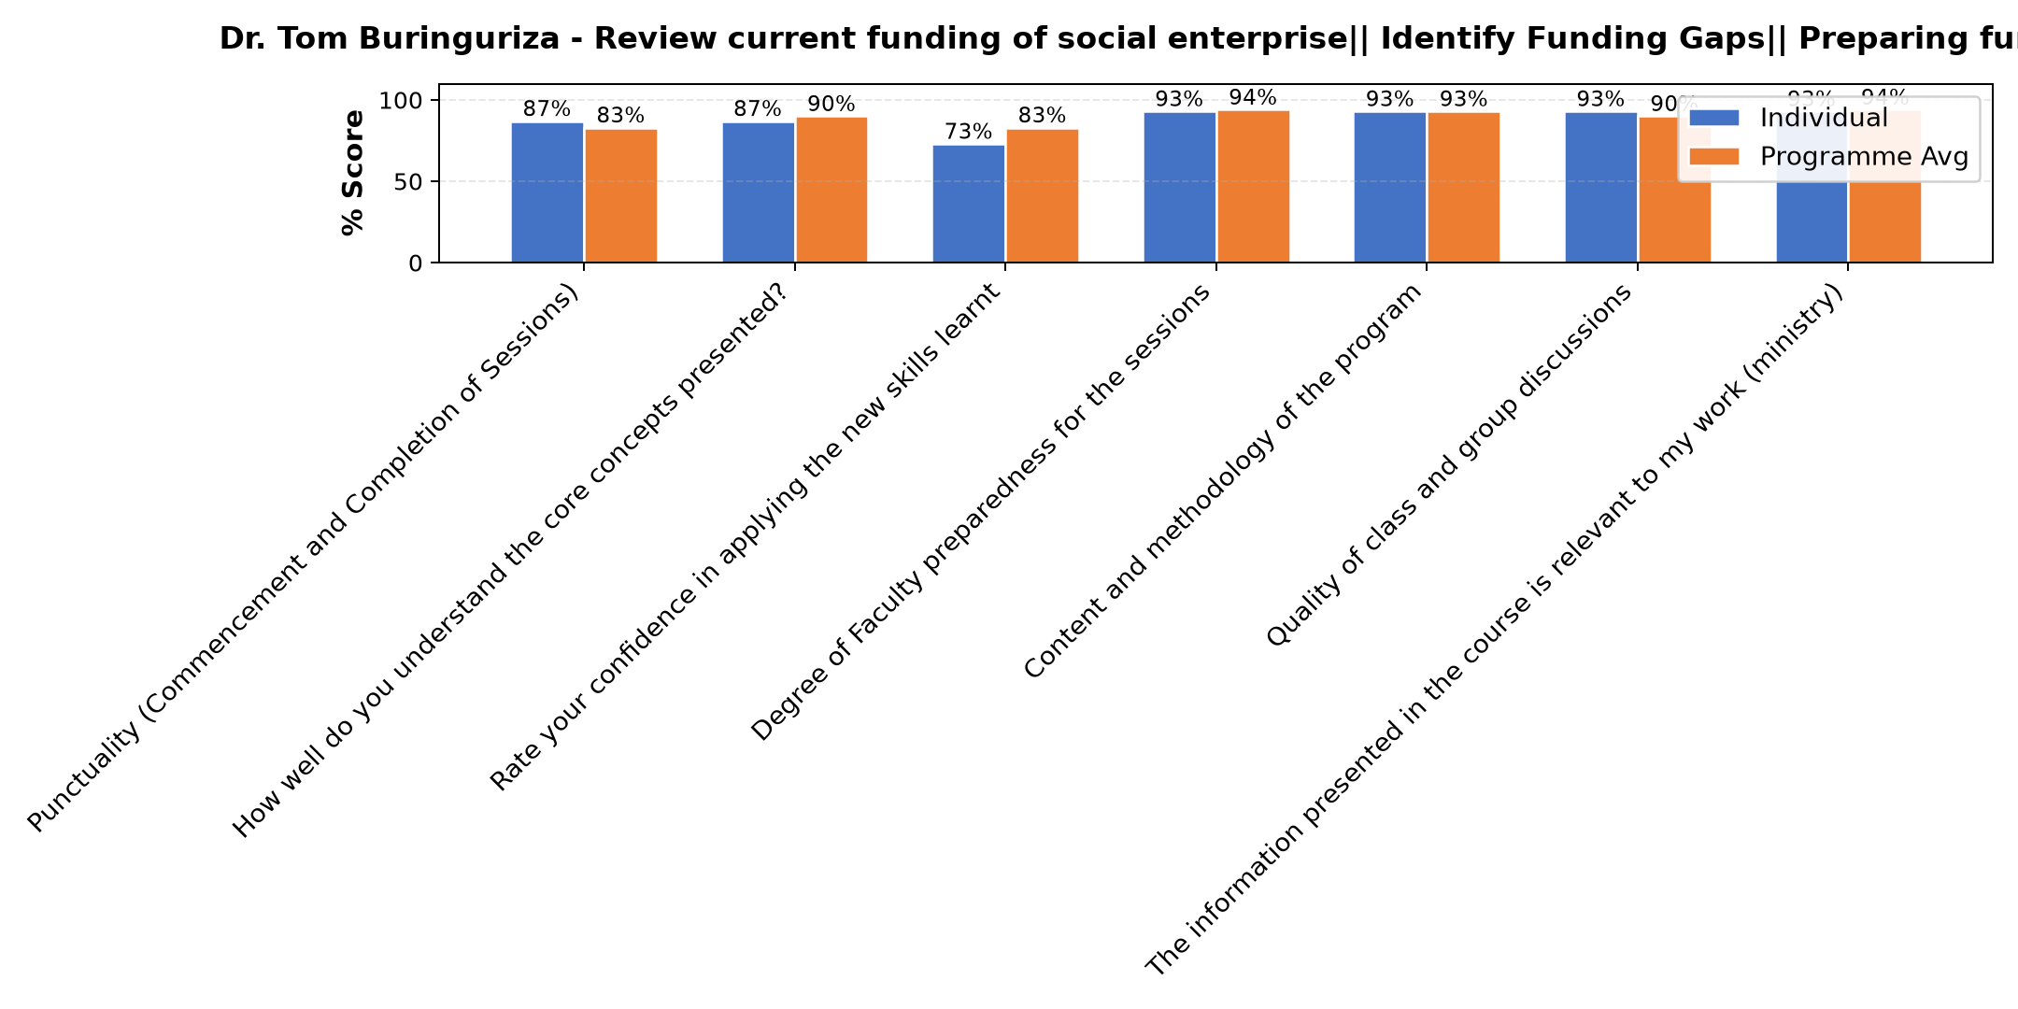

Comments & Feedback
- • I need to work hard to implement
- • When am not given chance

Dr. Cathy Mbidde - Social impact measures and planning
Evaluation Parameter | (%) Individual Score | (%) Programme Average
Punctuality (Commencement and Completion of Sessions) | 80 | 83
How well do you understand the core concepts presented? | 92 | 90
Rate your confidence in applying the new skills learnt | 88 | 83
Degree of Faculty preparedness for the sessions | 96 | 94
Content and methodology of the program | 92 | 93
Quality of class and group discussions | 88 | 90
The information presented in the course is relevant to my work (ministry) | 96 | 94
Average scores | 90 | 90

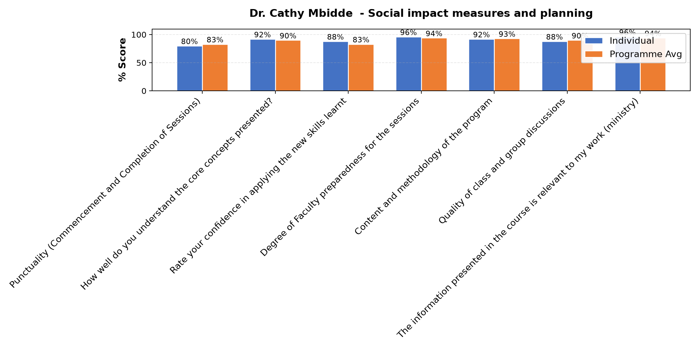

Comments & Feedback
- • Área competition, many schools around.
- • How to approach the donors

Department Reports

Are there any other comments and/or suggestions that you may want to add?

Comments & Feedback
- • Maybe next time, some they can't manage to get data , if possible there can be provision of data.
- • Overall, this was an incredibly enriching programme that has equipped us with practical tools to scale our social enterprise (school) sustainably. The facilitators were knowledgeable, approachable and generous with their expertise. I am deeply grateful to the Conrad N. Hilton Foundation, ACWECA and Strathmore Business School for investing in social entrepreneurs like us. We all look forward to applying these lessons and hope to continue being part of this community."
- • We need the follow up to see that the entreprise attain its sustainability
- • No
- • God bless you

Further Comments

Comments & Feedback
- • The information is very relevant for our social enterprise
- • God bless all the facilitators

Further Comments

Comments & Feedback
- • Well done to all and God bless all who contributed to this training.
- • A big thumbs Up for the continuous training you are giving us. Thanks for always bringing the best out of us.
- • The program is good and it's good to be passed on
- • Could it be more practical than it has been
- • Thanks
- • A very Deep seeking sharing
- • God bless u but u need to invite our superiors to learn such things

Further Comments

Comments & Feedback
- • Am grateful
- • Very impactful session, has help to know that we ignore very important aspects in our social enterprises. Thanks
- • Thank you

Overall Evaluation
Evaluation Parameter | (%) Score
Overall program evaluation | 97
Average score | 97

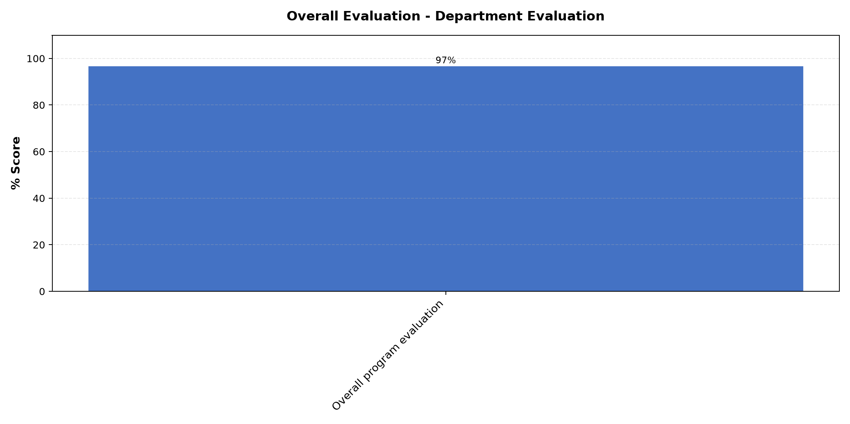

Comments & Feedback
- • The input is good
- • However, this programme has given us a stronger foundation and renewed confidence to tackle these barriers one step at a time. Please teach us on how to write proper projects.
- • Thank you
- • If possible to provide data for sisters because some of us is not easy to get it. God bless u.

What attracted you to the programme??

Comments & Feedback
- • Because it was all about social enterprise
- • We were attracted by the opportunity to learn structured strategies for scaling our school sustainably. The credibility of Strathmore Business School combined with the Hilton Foundation's focus on social impact aligned perfectly with our mission of expanding quality early education to more children in our community.
- • Down to earth not theory
- • Sustainability of socal enterprise

What topic would you recommend being expanded/improved in this programme’s units?

Comments & Feedback
- • Human resource management
- • Identifying Funding Gaps and Preparing a Funding Plan Long-term sustainability plan
- • Mision vision and goal
- • Records and accounts

Which areas in this programme did you find most important to your social enterprise?

Comments & Feedback
- • All
- • Financial sustainability
- • Funding & Preparation for Funding sessions and Long-term Sustainability Planning. As a growing school, securing reliable funding is critical to maintaining quality education and reaching more children. The sessions on identifying funding gaps and preparing a funding plan gave us practical tools we can try to immediately apply to our school's financial strategy.
- • Minimal
- • How to use what u have and save for long term sustainability

Which teaching methods applied in the course did you enjoy/learn from the most?

Comments & Feedback
- • Group discussions
- • The expert-led sessions were a highly practical, particularly when facilitators drew on real social enterprise examples that mirrored our own challenges.
- • Participation
- • Open sharing experiences

Program Manager (Matilda Maureen Biira )
Evaluation Parameter | (%) Score
Punctuality (Commencement and Completion of Sessions) | 97
How well do you understand the core concepts presented? | 97
Rate your confidence in applying the new skills learnt | 93
Degree of Faculty preparedness for the sessions | 100
Content and methodology of the program | 97
Average score | 97

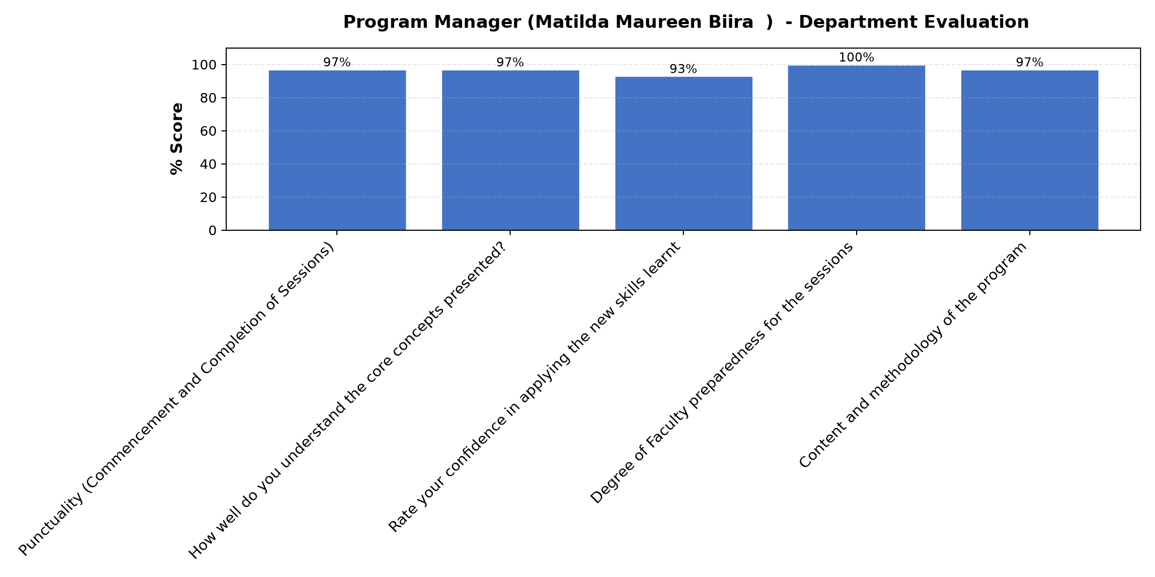

Comments & Feedback
- • Thank you for the input it was so wonderful and helpful.
- • We would like to sincerely appreciate Mrs Matilda who kept us on track throughout the week. Her constant reminders, prompt responsiveness, and willingness to help whenever we needed guidance made a tremendous difference in our learning experience. Having someone so dedicated behind the scenes ensured that participants like myself could focus fully on the content and get the most out of every session. She was truly the backbone of this programme and her support did not go unnoticed.
- • Thanks Matilda
- • She very responsible and passionate to this duty and to people

